Review: Newton’s Universal Gravitation: $F=G\frac{mM}{R^{2}}, G=6.674×{10}^{-11}\frac{N⋅m^{2}}{{kg}^{2}}$

Satellites in Circular Orbits - Orbital Velocity

Today there are many satellites in orbit around the Earth. The ones in circular orbits are examples of uniform circular motion. Like a model airplane on a guideline, each satellite is kept on its circular path by a centripetal force. The gravitational pull of the Earth provides the centripetal force and acts like an invisible guideline for the satellite.
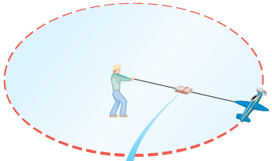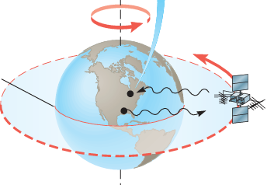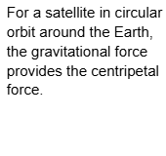

There is only one speed that a satellite can have if the satellite is to remain in an orbit with a fixed radius.

To see how this fundamental characteristic arises, consider the gravitational force acting on the satellite of mass m. Since the gravitational force is the only force acting on the satellite in the radial direction, it alone provides the centripetal force. Therefore, using Newton’s law of gravitation, we have:

$F_{c}=F_{G}$ , $\frac{mv^{2}}{R}=G\frac{mM_{E}}{R^{2}}$, $v=\sqrt{\frac{GM_{E}}{R}}$

where G is the universal gravitational constant, $M_{E}$ is the mass of the Earth, and R is the distance from the center of the Earth to the satellite. Solving for the speed v of the satellite gives the expression of the orbital velocity as above.
If the satellite is to remain in an orbit of radius R, the speed must have precisely this value: $v=\sqrt{\frac{GM_{E}}{R}}$Note that the radius R of the orbit is in the denominator. This means that the closer the satellite is to the Earth, the smaller is the value for R and the greater the orbital speed must be.

The mass m of the satellite does not appear in the expression of orbital velocity, having been eliminated algebraically. Consequently, for a given orbit, a satellite with a large mass has exactly the same orbital speed as a satellite with a small mass. However, more effort is certainly required to lift the larger-mass satellite into orbit.

Example 1:
31. Two satellites are in circular orbits around the Earth. The orbit for satellite A is at a height of 360 km above the Earth’s surface, while that for satellite B is at a height of 720 km. Find the orbital speed for each satellite.
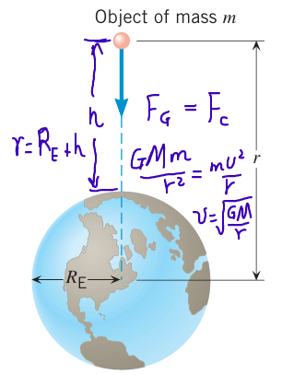

Example 2
During a lunar eclipse, the Moon, Earth, and Sun all lie on the same line, with the Earth between the Moon and the Sun. The Moon has a mass of 7.4 × 1022 kg; Earth has a mass of 6.0 × 1024 kg; and the Sun has a mass of 2.0 × 1030 kg. The separation between the Moon and the Earth is given by 3.8 × 108 m; the separation between the Earth and the Sun is given by 1.5 × 1011 m.

(a) Calculate the force exerted on Earth by the Moon.

(b) Calculate the force exerted on Earth by the Sun.

(c) Calculate the net force exerted on Earth by the Moon and the Sun.

Orbital Radius and Orbital Period-Kepler’s Third Law

The period T of a satellite is the time required for one orbital revolution. As in any uniform circular motion, the period is related to the speed of the motion by: $v=\frac{2πR}{T}$ , by using the centripetal force is the gravitation we obtian the orbital velocity: $v=\sqrt{\frac{GM}{R}}, Let \frac{2πR}{T}=\sqrt{\frac{GM}{R}}, then \frac{R^{3}}{T^{2}}=\frac{GM}{4π^{2}}$
$\frac{R^{3}}{T^{2}}=\frac{GM}{4π^{2}}$ is the Kepler’s Third Law
Example 3
35. A satellite is in a circular orbit about the Earth (${M_{E}=}^{}$ 6.0 × ${10}^{24}Kg,$ $R_{E}=6.37×{10}^{6}m$). The period of the satellite is $1.2×{10}^{4}s.$What is the speed at which the satellite travels?

Example 4
36. A satellite circles the Earth in an orbit whose radius is twice the Earth’s radius. What is the period of the satellite?

Example 5
2. A 2.10-kg brass ball is transported to the Moon. ( $R_{Moon}=$1.74 × 106 m and $M_{Moon}=$ 7.35 × 1022 kg.)
(a) Calculate the acceleration due to gravity on the Moon.

(b) Determine the mass of the brass ball on Earth and on the Moon.

(c) Determine the weight of the brass ball on Earth.

(d) Determine the weight of the brass ball on Moon.

Practice Problems for Orbital Velocity
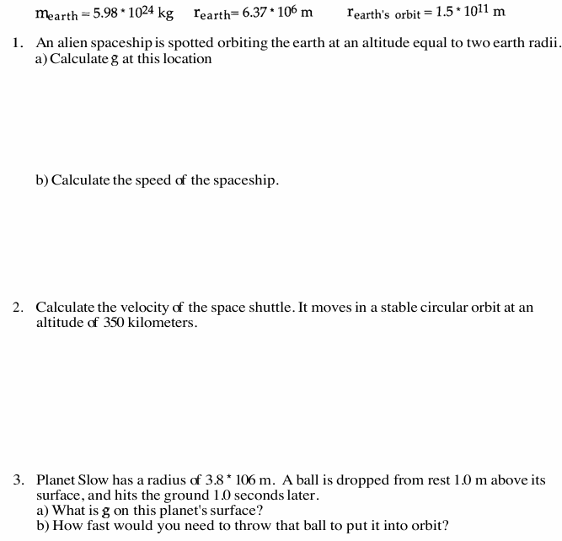

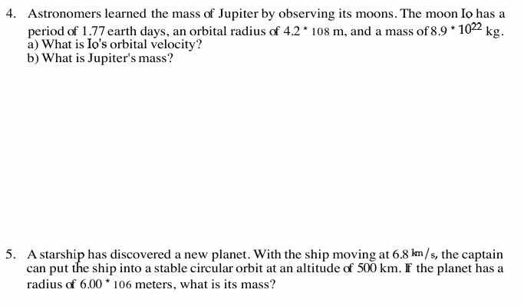

Kepler’s Law of Period
